**Department of Information Science & Engineering and CSE (Data Science)**

**Mini-Project Synopsis - Academic Year 2023-24**

| **1** | **Title of the Project** | Deep Learning-Powered Criminal Identification in CCTV Surveillance for Digital Crime Investigations |
| --- | --- | --- |
| **2** | **Team No** | CD05 |
| **3** | **Department** | Computer Science and Engineering (Data Science) |
| **4** | **Project Area/Domain** | Crime Investigation |
| **5** | **Project Type** | Software |
| **6** | **Name of the Students with USN** | 1.Lima Lolita Dsouza (4SF21CD013)  2.Adithi (4SF21CD002)  3.Nihara (4SF21CD018)  4.Mayur P S (4SF21CD016) |
| **7** | **Name of Guide** | Dr. Navaneeth Bhaskar |

**8. Abstract**

The proposed model is a sophisticated application of computer vision and facial recognition systems designed for criminal investigations. It involves the development of a robust system that takes a criminal's picture as input, breaks down CCTV video footage into individual frames, and identifies whether the criminal is present in the video. The core technique employed in the project leverages advanced algorithms by using CNN and Python libraries. These technologies enable real-time analysis and segmentation of CCTV video into frames, with a focus on intricate facial feature analysis for accurate identification. The primary application of this project is to streamline law enforcement efforts by automating the identification process of individuals in video footage. The system enhances the efficiency of criminal investigations, providing a quick and automated response to potential security threats. It stands at the intersection of artificial intelligence, machine learning, and surveillance technologies, contributing to the evolution of modern security practices.

**9. Introduction**

In today's world, where CCTV cameras are everywhere, there's a growing need for smarter technology to boost security and speed up criminal investigations. Our proposed model, an advanced criminal face identification system for CCTV surveillance, steps in to meet this demand. While CCTV cameras help monitor public spaces and important areas, going through all the video footage manually to identify people, especially those with criminal backgrounds, is slow and can lead to mistakes.

Our model relies on facial recognition technology, powered by advanced computer vision and deep learning, to address this challenge. It aims to create a sophisticated system specifically designed to quickly identify criminal faces in CCTV footage. The main goal is to change how we approach security and criminal investigations. By automating the identification process using advanced facial recognition algorithms, our model aims to significantly cut down the time and effort usually spent on manual reviews. We want to give law enforcement a powerful tool to speed up investigations, boost public safety, and contribute to making communities more secure. As we go further, we'll explore the specific challenges we're tackling, the techniques we're using, and the expected outcomes that position our initiative at the forefront of technological innovation in the fields of computer vision, artificial intelligence, and criminal investigations.

**10. Problem Statement and Description**

The rise of Closed-Circuit Television (CCTV) surveillance has overwhelmed law enforcement with an enormous amount of visual data. Manually sifting through this footage to identify criminal faces is slow, error-prone, and often leads to delays. The main problem is that traditional surveillance methods struggle to handle the sheer volume of video data and the need for quick and accurate identification of individuals with criminal backgrounds.

Our proposed model, which incorporates advanced face recognition algorithms, deep learning, and Convolutional Neural Networks (CNNs) directly tackles this challenge. The project aims to automate real-time criminal face identification, reducing investigation times, and enabling swift responses to security threats. By closing the gap between the growing demand for efficient surveillance and the limitations of current practices, our model offers a revolutionary solution for improved public safety and more efficient criminal investigations.

**11. Objectives**

* The primary objective of the work is to design a smart model for automatically identifying the criminals from CCTV footage and to ensure the model is capable of accurately identifying criminal faces within CCTV footage under diverse environmental conditions and lighting scenarios.
* To design a deep learning algorithm for detection of the criminals and to implement efficient data preprocessing techniques to enhance the system's responsiveness and reduce latency in face identification.
* To develop a user-friendly interface that enables easy input of facial images, initiate real-time identification processes, and provide clear and actionable results

**12. Methodology**

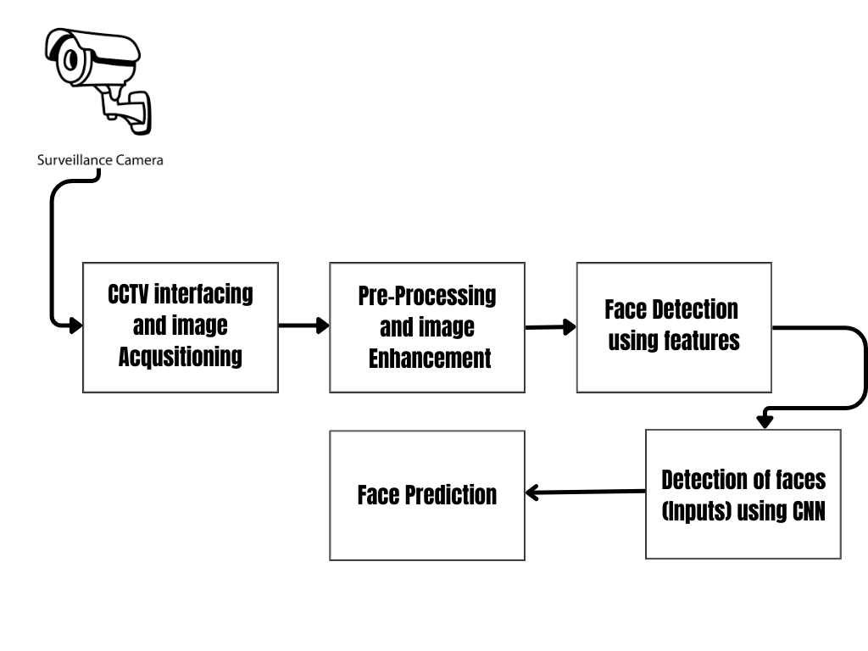

**13. Outcome of the work**

* The model will be utilized in crime investigation sectors where it will play a crucial role in predicting criminals
* Improved efficiency in criminal investigations by reducing the time required to identify persons of interest in video recordings.
* User-friendly interface for law enforcement agencies to easily interact with the system for real-time identification.
* Rapid identification of persons of interest aids in swift response to potential threats, allowing law enforcement to take proactive measures and mitigate risks promptly. This enhances the ability of law enforcement agencies to maintain a safer environment for the community.

**14. Conclusion**

The proposed model introduces an advanced application in computer vision and facial recognition tailored for criminal investigations. Its core objective is to take an individual's image as input, analyze CCTV video footage, and ascertain the person's presence in the video. This innovative approach simplifies law enforcement tasks, automates identification, and ensures quick responses to potential security threats. Situated at the crossroads of artificial intelligence, deep learning-CNN’s, and surveillance technologies, the project significantly contributes to modernizing security practices and optimizing criminal investigations.

**15. References**

1. Matsugu, M., Mori, K. and Suzuki, T., 2004. Face recognition using SVM combined with CNN for face detection. In *Neural Information Processing: 11th International Conference, ICONIP 2004, Calcutta, India, November 22-25, 2004. Proceedings 11* (pp. 356-361). Springer Berlin Heidelberg.
2. Tao, Q.Q., Zhan, S., Li, X.H. and Kurihara, T., 2016. Robust face detection using local CNN and SVM based on kernel combination. *Neurocomputing*, *211*, pp.98-105.
3. Wang, J. and Li, Z., 2018, July. Research on face recognition based on CNN. In *IOP Conference Series: Earth and Environmental Science* (Vol. 170, No. 3, p. 032110). IOP Publishing.

| **16** | **Signature of Students** |  |
| --- | --- | --- |
| **17** | **Signature of Guide** |  |
| **18** | **Signature of the Project Coordinator** |  |